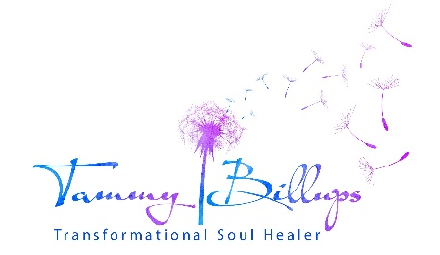
www.tammybillups.com ~ 770.235.6609
Thank you for your interest in the zoom 3-part masterclass learning series,
Healing Animals Emotional Wounds of Animals (& Their People)
Please provide the following information:
Name:
Address:
City:
State: Zip:
Email Address:
Phone:
- How did this class find you?
- List the quantity and types of animals you share your life with.
- Do you have an animal-related business, or work/volunteer with animals? Please elaborate.
- Do you or have you ever volunteered at an animal organization? Yes/No
- Would you say that you get emotionally close to animals? Yes/No
- Have you worked with Tammy before? For yourself and/or your animal(s)?
- Have you previously attended one of Tammy’s workshops or meditation groups?
- Do you have specific physical or behavioral issues with the animals under your care that you want to resolve?
- Have you read the required excerpt? Yes/No
- What are your hearts intentions for what you are hoping to learn in this class? (Suggestion: Sit quietly with both of your feet on the ground. Take several deep breaths directly into your heart. Then ask your heart what it is most hoping to learn.)
Class time/dates (Eastern times):

Part One-Thursday, June 9th, 7:00-9:00pm

Part Two-Thursday, June 16th, 7:00-9:30 pm

Part Three-Thursday, June 23rd, 7:00-9:30pm
All classes will be recorded and provided to those that have events preventing them from attending.
You will be sent a short survey form upon completion of the series so Tammy can fine tune her online class series and she is very grateful for your quick turnaround of the post-class survey.
This learning series includes copywritten material and handouts that cannot be shared.
Please email this completed form to tammy@tammybillups.com. If you do not hear back from Tammy within 48 hrs. confirming receipt of your application, please check your spam account for her email, or reach out to her via phone.

