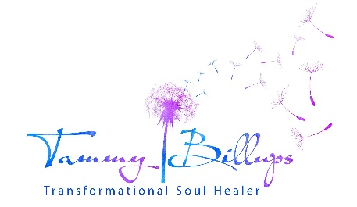
www.tammybillups.com ~ 770.235.6609
Thank you for your interest in the zoom 4-part class learning series, Sacred Soul Contracts, based on the teachings in the book, Animal Soul Contracts.
Please provide the following information:
Name:
Address:
City:
State:
Zip:
Email Address:
Phone:
- How did this class find you?
- List the quantity, types, and names of the animals you share your life with.
- Is there a particular animal/issue you’re hoping to find peace around through learning of your soul contracts with that animal? (Please share the issue)
- Do you have an animal-related business, or work/volunteer with animals? If yes, please elaborate.
- Have you worked with Tammy; previously attended one of her classes, or read either of her books? (Not required) If yes, please elaborate.
- Are you able to attend all dates? If not, which one(s) will you need a recording emailed instead?
- What are your hearts intentions for what you are hoping to learn in this class? (Suggestion: Sit quietly with both of your feet on the ground. Take several deep breaths directly into your heart. Then ask your heart what it is most hoping to learn.)
Class time/dates (Eastern times). Dates for March/April 2022:

Part One- 3/24/22 Thursday 6:00-8:30pm

Part Two- 3/31/22 Thursday, 6:00-8:30pm

Part Three- 4/7/22 Thursday, 6:00-8:30pm

Part Four- 4/14/22, Thursday, 6:00-8:30pm

All classes will be recorded and provided to those that have events preventing them from attending.
You will be sent a short survey form upon completion of the series so Tammy can fine tune her class as this will be repeated in the future. Please send this to Tammy within a week of receiving it.
This learning series includes copywritten material and handouts that cannot be shared.
Please type or sign your name that you have read and agree to the previous two statements. _________________________________________
***Email this completed form to tammy@tammybillups.com. If Tammy doesn’t respond within 48 hrs. confirming receipt of your application, please check your spam account for her email, or reach out to her via phone. 770.235.6609

Click here to read an excerpt from chapter 4, Types of Soul Contracts Defined; from the book Animal Soul Contracts – Sacred Agreements for Shared Evolution.

